

Types of Tooth

Name: Date:

- Use the word bank below to help label the teeth…

- Complete the following sentences.

Incisors are used for ____________ and ____________.

Canines are used for ____________ and ____________.

Molars are used for ____________, ____________ and
____________.

ripping | canine | wisdom tooth | crushing
chewing | premolar | biting | cutting
incisor | tearing | grinding | molar

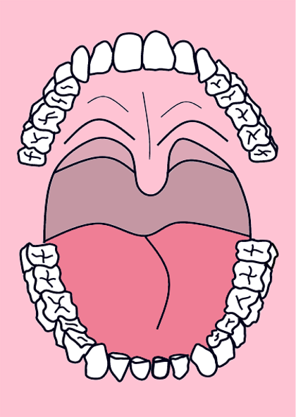
© 2006 First School Years (www.firstschoolyears.com) This resource may be photocopied for educational purposes.

