
Farm Animals

Name: Date:

- Name the farm animals using the words below.
2003 First School Years (www.firstschoolyears.com) This worksheet may be reproduced without permission for educational use.

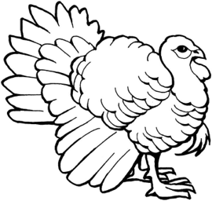 | 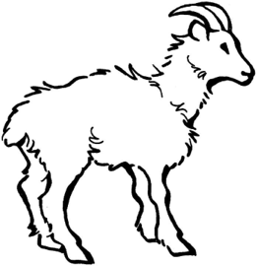 | 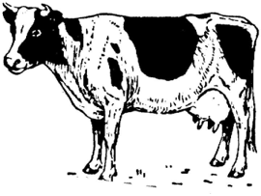
__ __ __ __ __ __ | __ __ __ __ | __ __ __
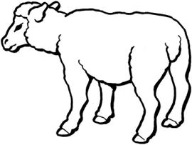 | 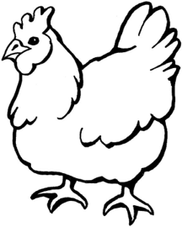 | 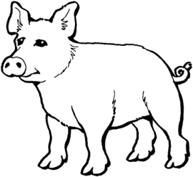
__ __ __ __ __ | __ __ __ __ __ __ __ | __ __ __

c h i c k e n | s h e e p | t u r k e y
p i g | g o a t | c o w

- Circle the animals which might also be found on a farm.

duck tiger sheepdog elephant whale horse giraffe

