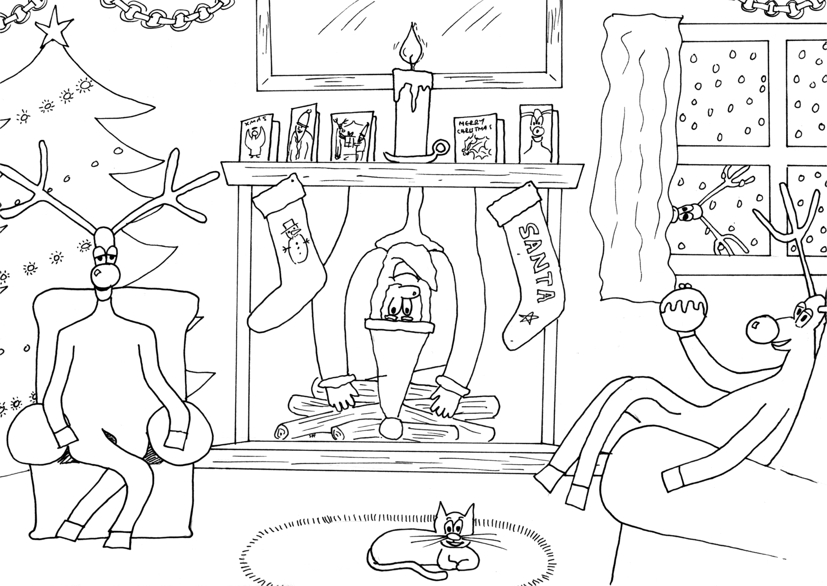

2004 First School Years (www.firstschoolyears.com)
Artwork by S. Fitton

