
Initial Sounds (1)

Name: Date:

- Circle the correct initial sound for each word…
2002 First School Years (www.firstschoolyears.com) This worksheet may be reproduced without permission for educational use.

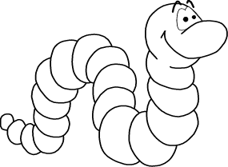 | 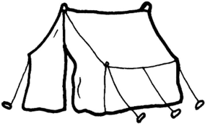 | 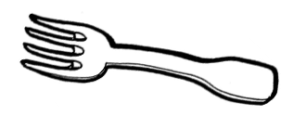
r t w f | p t c l | f v a n
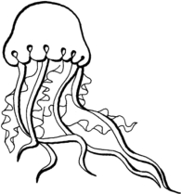 | 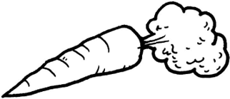 | 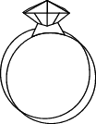
k g b j | f s o c | w r h i

- Draw a picture for each of the following initial sounds…

s | h

