

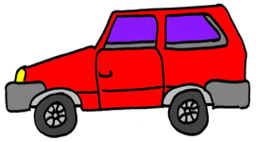
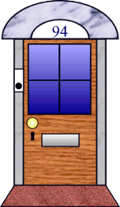

©2001 First School Years (www.firstschoolyears.com)
©2001 First School Years (www.firstschoolyears.com)
©2001 First School Years (www.firstschoolyears.com)
©2001 First School Years (www.firstschoolyears.com)


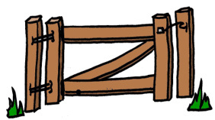
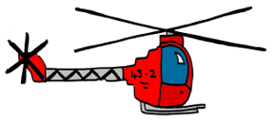
©2001 First School Years (www.firstschoolyears.com)
©2001 First School Years (www.firstschoolyears.com)
©2001 First School Years (www.firstschoolyears.com)
©2001 First School Years (www.firstschoolyears.com)




©2001 First School Years (www.firstschoolyears.com)
©2001 First School Years (www.firstschoolyears.com)
©2001 First School Years (www.firstschoolyears.com)
©2001 First School Years (www.firstschoolyears.com)




©2001 First School Years (www.firstschoolyears.com)
©2001 First School Years (www.firstschoolyears.com)
©2001 First School Years (www.firstschoolyears.com)
©2001 First School Years (www.firstschoolyears.com)

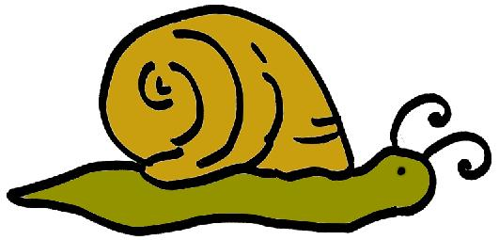

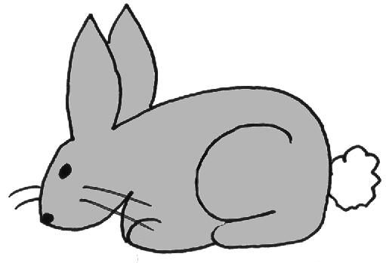
©2001 First School Years (www.firstschoolyears.com)
©2001 First School Years (www.firstschoolyears.com)
©2001 First School Years (www.firstschoolyears.com)
©2001 First School Years (www.firstschoolyears.com)
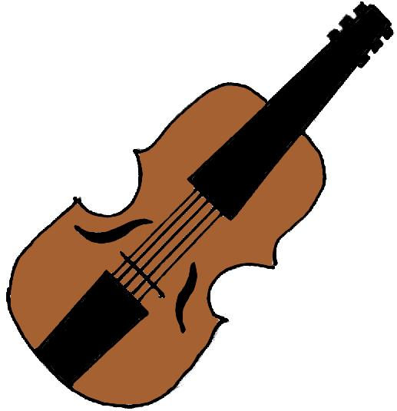



S
©2001 First School Years (www.firstschoolyears.com)
©2001 First School Years (www.firstschoolyears.com)
©2001 First School Years (www.firstschoolyears.com)
©2001 First School Years (www.firstschoolyears.com)


©2001 First School Years (www.firstschoolyears.com)
©2001 First School Years (www.firstschoolyears.com)

